|  |
| --- |
| EMBBEDED SYSTEMS SPECIALIZATION PROGRAMM |
| Task 1 – Task Scheduler into Cooperative |
| Operating Systems Design for Embedded Environments |

|  |
| --- |
| **Student Name 1**  Email: [se723375@iteso.mx](mailto:se723375@iteso.mx)  **Student Name 2**  Email: [student2_email@iteso.mx](mailto:student2_email@iteso.mx) |

**06/09/2018**

Embedded Systems Specialization Program

[www.sistemasembebidos.iteso.mx/alumnos](http://www.sistemasembebidos.iteso.mx/alumnos)

I T E S O A. C., Universidad Jesuita de Guadalajara

Periférico Sur Miguel Gómez Morín #8585, Tlaquepaque, Jalisco, México

Technical Report Number: ESE-O2014-001

® ITESO A.C.

|  |
| --- |
| ***Abstract:*** *In this document there will be a description of the process entailed to modify a non-preemptive scheduler into a preemptive scheduler.* |
| ***Keywords:*** *scheduler. Preemptive. Embedded..* |

# Table of Contents

1. Table of Contents ii

2. Table of Figures iii

3. Introduction 1

3.1. Requirements 1

4. Functional Description 2

5. Results 3

6. Conclusions 4

# **Table of Figures**

Figure 5.1 Example of Figure Caption 1 3

# Introduction

Place a brief introduction of the project to realize.

## Requirements

Place you requirements in this section.

Table 1.1 Example of Table Caption 1

|  |  |  |  |
| --- | --- | --- | --- |
|  |  |  |  |
|  |  |  |  |

# Functional Description

Place a functional description of your solution.

Table 2.1 Example of Table Caption 2

|  |  |  |  |  |
| --- | --- | --- | --- | --- |
|  |  |  |  |  |
|  |  |  |  |  |

# Results

Place a description of your solutions and (if available) some figures such as screen captures as evidence of your working project.

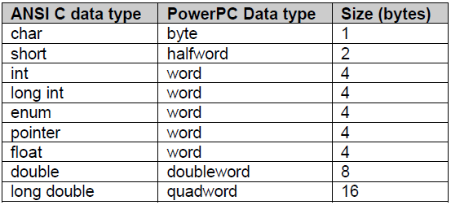

Figure 5.1 Example of Figure Caption 1

# Conclusions

Place your conclusions such as what you have learned, suggestions like improvements of your work, etc.